**Event Management System**

**Abstract:**

Online event management system is an online even management system software project that serves the functionality of an event manager. The system allow only registered user login and new user are allowed to register on the application .This proposed to be a web application. The project provides most of the basic functionality required for an event type e.g. [marriage, Dance Show birthday party, etc.], the system then allows the user to select date and time of event, place and the event equipment. All the data is logged in the database and the user is given a receipt number for his booking. The data is then send to administrator (website owner) and they may interact with the client as per his requirement.

**Keywords-**

User, Event Management, Database

**I. INTRODUCTION**

Event management is the application to manage and development of festivals, events and conferences. Proposed work Involves study of identifying the target of budget, cost, and analysis. Post event analysis and ensuring a return on investment have become significant drivers for the event industry. This is an online event management system, software project that serves the functionality of an event manager. The project provides most of the basic functionality required for an event .It allows the user to select from list of event types. Events Management System is very helpful for events. This application being as a platform to know the events, to apply for the events. Event organizer is an application under project management for managing festivals or social events like gathering, colleges, events, conference etc. To understand use of this application consider the flow ofactions happening, by this application user can register the students, after registering, user can login, after login, event details including name ,contact, address, venue of the event, date, event conducting time, cost of events etc. After receiving SMS student can register through application.

|  |  |
| --- | --- |
| Website | Reviews |
| www.eventbusinessacademy.com | Creation, direction and planning of all kinds of event |
| www.pcmag.com | Monitors, servers workstations and network device for routine and non routine event |
| www.eventpro.net | Booking system with a fiddly little catering add on |
| www.event.com | It helps to view sample event websites created with event’s |
| www.eventbrite.com | Their event plan software act as a virtual event manager |

**II. LITERATURE SURVEY**

**III. PROPOSED WORK**

This web based application system can be implemented in hotels, clubs for booking events. The system can also be used as software to promote the entire booking places. The user gets all the resources at a single place instead of wondering round for these. This system is effective and saves time and cost of the user.

**A. Modules Description**

**Admin Login**: Admin view, updates, delete customer and vendor’s records .admin view update booking record, verify email and massages, receipt mail. If any vendors rating will constantly not good then admin can remove vendor.

**Registration:** In the users and vendors registration form, the users and vendors has to enter the users and vendors name, address, email identification and the phone number. The users and vendors details are allowed to store in the centralizeddatabase with an automatic generated event id.

**Check Availability**: In the check availability module user check the availability of the halls and then book the hall for their event.

**Customer:** In the customer module customer doing own registration , login , search event view , update , delete own profile, select event date and time, select event , select place, select equipment, select food packages, book event, view confirmation mail , change password. Search is optional they can search event without login. After booking vendors provide notification like book successfully and then logout. Websites provides all the details about budget of hall.

**Vendors**: Vendors register, login, view, insert, update, delete own profile, confirm booking of event for customer. Vendors manage events, manage places, manage equipment, manage food, and Send notification of event booking to customer. They can see the reviews provided by customer after organizing event successfully

B. Class Diagram:

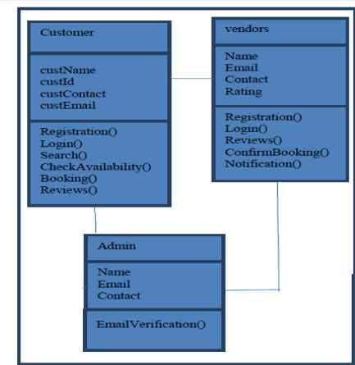

**B. Data Flow Diagram**

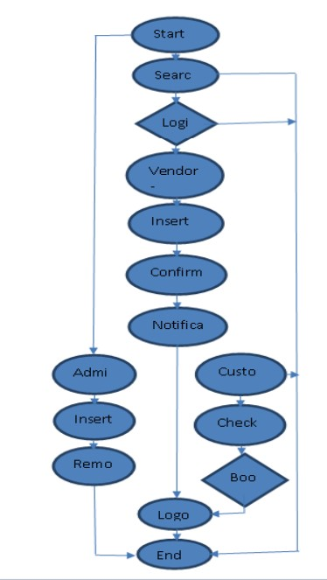

**IV. ADVANTAGES**

* Reduce time for finding location
* User Friendly GUI
* This system is effective and provide best of the cost to user.
* Save Time In Communication
* Efficiently Manage Multiple Events

**V. APPLICATION**

* Can be used in to organizing events in school & colleges.
* Organizing Social Events. Etc.
* To the creation and development of large scale events such as festivals, conferences, ceremonies, formal parties, concerts or conventions.
* Event planning and which can include budgeting, scheduling, site selection, acquiring necessary permits, coordinating transport and parking.
* Its involves studying the brand, identifying the target audience, devising the event concept, and coordinating the technical aspects before actually launching the event.

**CONCLUSION**

In this project, we made attempt to effectively introduce the concept of event management systems already existing in the society. We then explain the concept of online event management systems which are already present. We describe the proposed system and explain the features implemented by our proposed system .We also give a brief overview of the technologies used during the development of our proposed system. Finally, we illustrate the working of our proposed system in Section IV. This project can be further refined and extended by introducing new and more innovative features.

**Acknowledgement**

The authors sincerely thank Prof. Madhuri Dubey for her Expert guidance and support throughout the work. The Authors also thank college of Information Technology and Engineering and RTMNU University for the infrastructure andSupport provided.

**References**

[1] Cristian CIUREA, "Implementing an Encryption Algorithm in Collaborative Multi cash Service desk Application", Open Source Science Journal, Vol. 2, No. 3, 2010.

[2] Fauzan Saeed, Mustafa Rashid, "Integrating Classical Encryption with Modern Technique", IJCSNS International Journal of Computer Science and Network Security, VOL.10 No.5, May 2010

[3] Kullaprapa Navanugraha, Pornanong Pongpaibool, Chalee Vorakulpipat, Nuttapong Sanglerdsinlapachai, Nutvadee Wongtosrad, Siwaruk Siwamogsatham,

“The Deployment ofthe Auto-ID System in a Conference”, PICMET, IEEE, pp.1-7, 2010

[4] L. McCathie and K. Michael, “Is it the End of Barcodes in Supply Chain Management?”, Proceedings of the Collaborative Electronic Commerce Technology and Research Conference LatAm, 2005

[5] Lung-Chuang Wang, “Enhancing construction quality inspection andmana gementusing RFID technology”, Journal Automation in Construction, Elsevier, pp. 468-469, 2008

[6] Paul M. Swamidass, “Bar Code Users and Their Performance”, White Paper, UNOVA Inc., 1998

[7] Roozbeh Derakhshan, Maria E. Orlowska and Xue Li, “RFID Data Management: Challenges and Opportunities”, IEEE International Conference on

RFID, 2007

[8] Zebra Technologies, “It‟s All In The Wrist:

Improving Patient Safety With Barcode Wristbands”,

White Paper, Zebra Technologies, 2013

**OUTPUT**

